Practice Sheet: Unit-1
- Sketch the following signals
- x(n)= [5 2 3 4 8]
- x(n)= x(n+7)
- Sketch the following signals x(n)= 2^{n} -2<n<8
- x(n)+ δ(n-1)
- u(n-1) δ(n-1)
3. Which of the following should be done in order to convert a continuous-time signal to a discrete-time signal?
(a)Quantization (b)sampling (c) Encoding (d) None of these
4. Which mathematical notation specifies the condition of periodicity for a continuous time signal?
(a) X(t) (b) X(n+N) (c) X(t+T0) (d) X(t-T0)
5. Find the energy and Power of a signal
x(t)= Ae^{-at}
6. Check whether the signal is even or odd
x(t)= e^{-3t}
7. Check whether the signal is periodic or aperiodic
x(t)= cos (3πt)+sint
8. Check whether the signal is periodic or aperiodic?
- Sin3n
- Cos 2πn
- Cos (n/8) cos (nπ/8)
- Cos 0.01πn
9. Check whether the signals are energy signal or power signal?
- u(t)-u(t-4)
- n u(n)
- 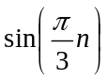
10.Find the even and odd components of the following signals:
- x(t) =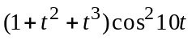
- x(t)=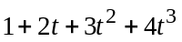
11. Find the even and odd components of the following signals:
x(n)=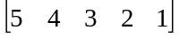
12. Find which of the following signals are causal or non-causal.
- x(t)=u(t+2)-u(t-2)
- x(t)=cos2t
- x(n)=u(-n)

